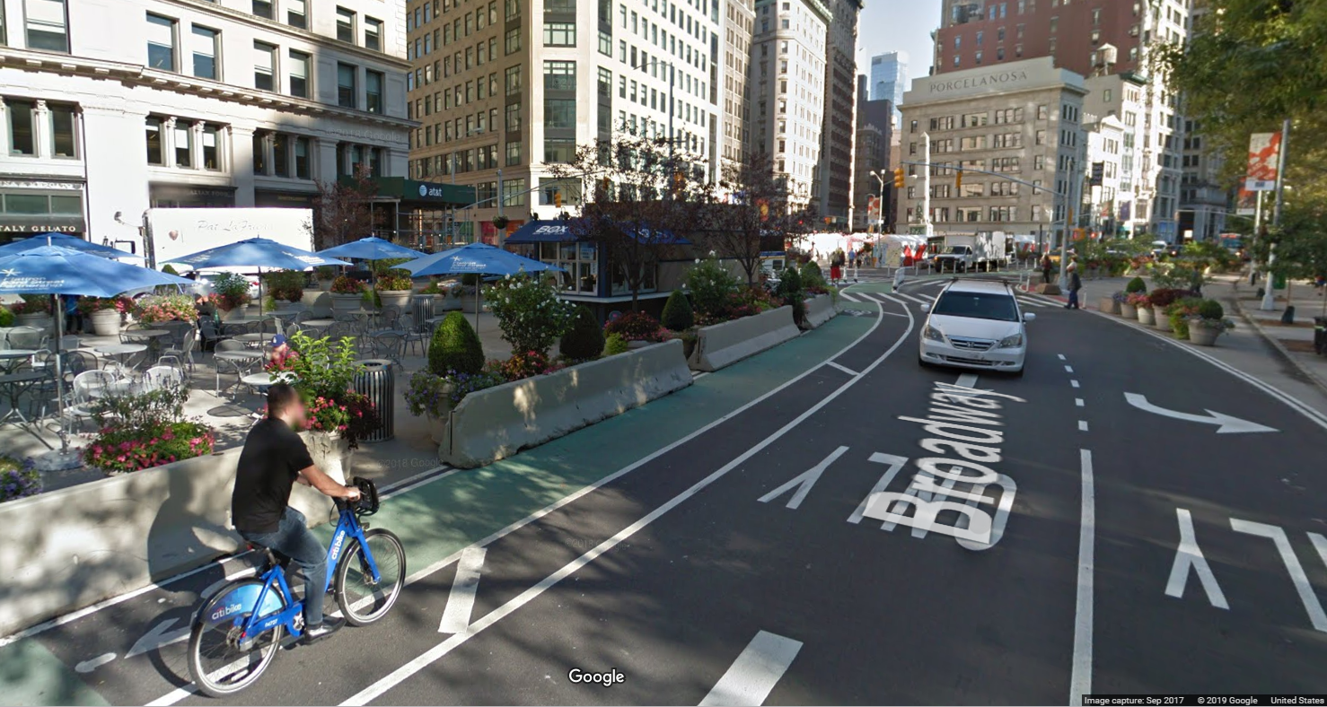

 Rider

Quarterly Report Q1 2019

|  |
| --- |
|  |
|  |
| June 12  Published by:  CitiBike Data Collection Center  NYC Department of Transportation  Authored by:  Rob Phillips |

# Safe Rider News

|  |
| --- |
| Health and Safety Check Since the publication of [Safer Cycling: Bicycle Ridership and Safety in New York City](http://www.nyc.gov/html/dot/downloads/pdf/bike-safety-study-fullreport2017.pdf) released in 2017, the [NYC DoT](https://www1.nyc.gov/html/dot/html/bicyclists/bicyclists.shtml) continues to evaluate cyclist health and safety data collected by the CitiBike Data Collection Center (DCC).  As we continue to gather more data daily, the CitiBike DCC monitors, analyses and reports key rider health and safety information to NYC Planning and our cyclist community. CitiBike Rider is a quarterly report of these findings, and highlights important information which directly contributes to [Bike Smart](https://www1.nyc.gov/html/dot/html/bicyclists/biketips.shtml) and the [Vision Zero](https://www1.nyc.gov/site/visionzero/index.page) Action Plan. |
| *“The Vision Zero Action Plan is New York City's foundation for ending traffic deaths and injuries on our streets”* |
| Making Data Count  |  | | --- | | CitiBike Trip Data Every time a CitiBike bicycle is rented from a station, some essential data is logged to better inform rider health and safety. This includes the time of day, rider age and gender, station location, duration and distance of each trip. | | *“Every CitiBike Station and bicycle rental provides key data”* |   The true heartbeat of the Big Apple is its people. Each quarter we examine bicycle movements by station and zip code to identify increases in the number of riders. Between 2006 and 2015, the number of cyclist trips increased from 66 million to 164 million. We forecast the number of cyclist trips will exceed 250 million by the year 2025.  This means that our roadways will need to accommodate 150% more cyclist traffic over the next 6 years. This is a significant challenge for one of the largest island cities on the planet, where space is not only vital for the lifestyle for millions of residents, but also highly constrained and precious for their health and wellbeing. |
| Rider Preference  |  |  | | --- | --- | | By The Numbers Whether for exercise, the commute, or leisure, CitiBike Bike Share provides an eco-friendly means of individual transport across NYC. CitiBike riders have already indicated their [Bike Share pass preferences](https://public.tableau.com/profile/robbie.phillips#!/vizhome/PassPurchases2014-2018/PassPurchases?publish=yes) to suit their lifestyle over the past 5 years.    Figure 1: Preference for 7-Day Passes and Annual memberships (bold) diminished with the introduction of 24-Hour and 3-Day Passes   |  | | --- | | Cyclist Demographics As we dig deeper into [Pass Purchases by Gender](https://public.tableau.com/profile/robbie.phillips#!/vizhome/CitiBikeTrips/PassPurchasesByGender?publish=yes), it is evident that the most frequent riders are males making daily trips on a 24-Hour Pass. While the 3-Day Pass have only increased marginally in popularity following discontinuation of the 7-Day Passes in 2016.  A close up of a map  Description automatically generated  Figure 2: The 24-Hour Pass is most popular particularly for male (Gender 1) cyclists.  While protecting the privacy of individual riders, the CitiBike DCC does not collect personal information regarding the purpose of bicycle rentals. It does however, track the miles travelled, the start time and duration of each trip, and the start and end station locations. [From this data](https://public.tableau.com/profile/robbie.phillips#!/vizhome/CitiBikeTrips/MilesTravelledByGender?publish=yes) we are able to determine profiles of bicycle usage, including the total number of miles travelled to date for males, females, and other/non-identified gender.  Comparing the proportion of male to female miles per 24-Hour pass, there is only a 2% difference between the average miles travelled by gender. This means that while males may be the predominant bicycle renters (see Figure 3), the average distance travelled on a 24-Hour pass is quite consistent regardless of gender.    Figure 3: Male cyclists have logged over 15 billion miles more than other genders, due only to the disproportionate number of male renters.    The Safer Cycling report breaks the female rider data down to Bike Share stations by neighborhood to examine more popular areas for female riders. This earlier analysis identified these areas as less congested and with better connected bicycle facilities.  Smart Moves!  *“Female riders choose less congested neighborhoods with better connected bicycle facilities”* |  Shifting GearsGoing the distance As we dig deeper into [Pass Purchases by Gender](https://public.tableau.com/profile/robbie.phillips#!/vizhome/CitiBikeTrips/PassPurchasesByGender?publish=yes), it is evident that the most frequent riders are males making daily trips on a 24-Hour Pass.    Figure 4: Younger males travel more frequent and shorter periods daily,  indicating a common purpose for bicycle rental may be for commuting. | | *“Every CitiBike Station and bicycle rental provides key data”* |   To get started right away, just tap any placeholder text (such as this) and start typing to replace it with your own.  Want to insert a picture from your files or add a shape, text box, or table? You got it! On the Insert tab of the ribbon, just tap the option you need. |
| Happy Makes Healthy  |  | | --- | | Cyclist Demographics Whether for exercise, the commute, or leisure, Bike Share provides an eco-friendly means of individual transport for all ages and gender.  A close up of a map  Description automatically generated  As we continue to gather more data daily, the CitiBike DCC monitors, analyses and reports key rider health and safety information to NYC Planning and our cyclist community. CitiBike Rider is a quarterly report of these findings, and highlights important information which directly contributes to [Bike Smart](https://www1.nyc.gov/html/dot/html/bicyclists/biketips.shtml) and the [Vision Zero](https://www1.nyc.gov/site/visionzero/index.page) Action Plan. | | *“Every CitiBike Station and bicycle rental provides key data”* |   To get started right away, just tap any placeholder text (such as this) and start typing to replace it with your own.  Want to insert a picture from your files or add a shape, text box, or table? You got it! On the Insert tab of the ribbon, just tap the option you need. |